**Activities for modal verbs.**

The proposed activities are for all types of students, as we know there are visual, auditory and kinesthetic so we must adapt the activities with what we have, here are some suggestions that might be useful.

**Language skills that students can develop when using them:**

Listen, speak, read and write.

Values: collaboration.

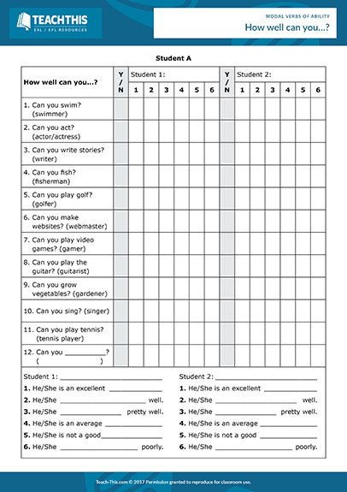In this modal verb of ability worksheet activity, students practice talking about skills and levels of ability using modal verbs and adverbs of manner. Divide the students into pairs (A and B) and give each student a corresponding worksheet. Students take it in turns to ask their partner 'Can you...?' questions and mark their responses on the worksheet. When their partner replies 'Yes, I can', the student asks a 'How well can you...?' question. Their partner responds with one of six phrases on the board that express their level of ability and the student ticks the appropriate 1 to 6 boxes on the worksheet. If their partner replies 'No, I can't', the student moves on to the next 'Can you...?' question. When everyone has finished, the students form new A and B pairs and write the name of their new partner’s former partner on the worksheet. The students then ask and answer questions about their new partner’s former partner using the third person singular, e.g. 'Can he swim?' When the students have finished, they complete sentences at the bottom of the worksheet with information about the students' levels of ability.

If our students are visual, we can project this video where we talk about manners, which can be written down by the students and spoken to at the end of the class. Involving them will possibly make them learn faster.

<https://www.youtube.com/watch?v=2oumWdjA9hM&t=85s>

Kahoot game

<https://create.kahoot.it/details/20830b18-6334-4e56-b270-112550142e0a>

The most important thing is to adapt it for our students and for them to learn.